?

STYLE NOTES FOR AUTHORS FOR THE
PREPARATION OF FULL-PAPER

First-name1 Last-name1, Affiliation1, Country1
First-name2 Last-name2, Affiliation2, Country 2
First-name3 Last-name3, Affiliation3, Country 3

KEYWORDS: keyword1, keyword2, keyword3, keyword4, keyword5, keyword6

ABSTRACT

Your paper should not exceed 9 pages in A4 size. Please prepare your paper in Times New Roman typeface. The body of the text should be prepared as this example in 12 point. Leave 0.95 inch margins on top and bottom, and 0.98 inch margins on left and right. Text should be justified (across whole page width).
Please begin the chapter with a descriptive abstract (50-100 words) summarizing the content of the article and indicate the abstract with the heading ABSTRACT. Other essential headings include: INTRODUCTION; ………………………..CONCLUSION (not Conclusions; not Discussion; not Concluding Remarks); REFERENCES and any other headings deemed necessary within the chapter to reflect the important subsections or divisions.

HEADINGS

Main headings should be typed in bold in 15 point for first letter of each word and 12 point capitals for subsequent letters, aligned left. Leave two lines above and one line below main headings. And no chapter numbers should be used for any headings.

Subheadings

Subheadings should be typed in bold 12 point upper and lower case, aligned left. Leave one line above and one line below subheadings.

Subsubheadings. Subsubheadings should be typed in italicised 12 point upper and lower case. The following text should run on after a full stop. Leave one line before subsubheadings.

TABLES

Tables must be set as part of the text and centred. The main text should be in Times New Roman. Titles and headings are to be set in Times New Roman, 12-point type. All tables must have a caption centred over the table and should be numbered sequentially as Table 1, Table 2, Table 3, etc. Leave one line space above and below tables. Large tables may be set in landscape, sideways on the page, reading up. Please use the English notation for numbers. When referring to tables in the text, preface the number with the word ‘Table’ or ‘Tables’ and place the number as Table 1, Tables 4 and 5, etc in plain style (not bold).

Table 1. An example of the table
Column A | Column B | Column C
Row 1A | Row 1B | Row 1C

DISPLAYED EQUATIONS

All equations must be clearly set. When referring to equations in the text, preface the number with the word ‘equation’ or ‘equations’ and place the number within brackets as equation (1), equations (4) and (5), etc. Displayed equations should be numbered simply (1), (2), (3), etc. The numbers should appear at the extreme right of the line. Please ensure that subscripts and superscripts are clearly legible.

$A^{i}=B+C$ (1)

FIGURE CAPTIONS

Captions to figures/illustrations should be set in Times New Roman and centred below the figure. All figures are to be numbered sequentially as Figure 1, Figure 2, Figure 3, etc. When referring to figures in the text, preface the number with the word ‘Figure’ or ‘Figures’ and place the number as Figure 1, Figures 4 and 5, etc. Leave one line space above figure and after caption.

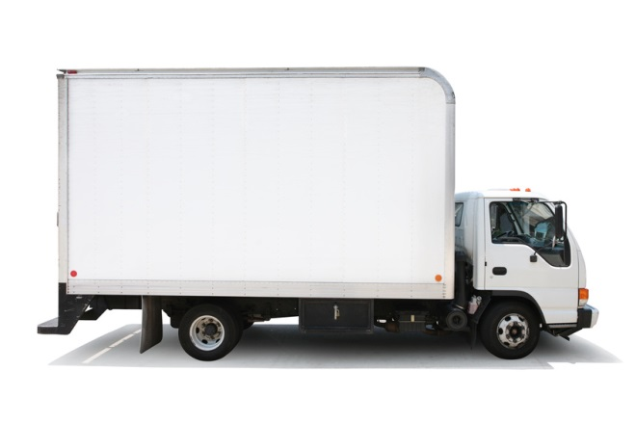
Figure 1. This is a test figure
a. | b.
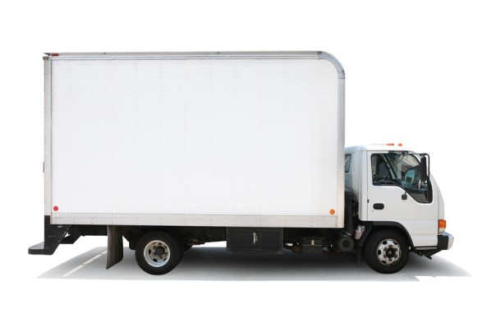 | 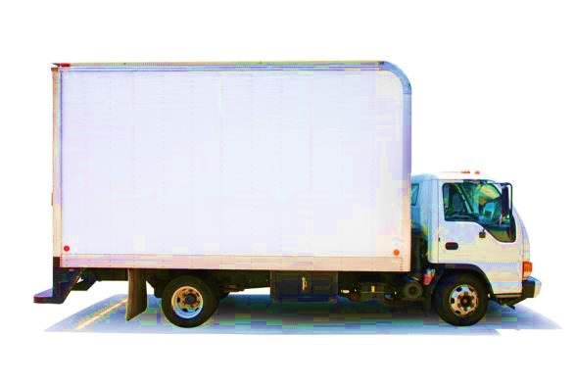
Figure 1. (a) This is the first figure; (b) This is the second figure

FIGURES/ILLUSTRATIONS

Colour graphics can be used in your manuscript. Graphics must fit within the page text size. Try to avoid boxing text between two illustrations on a page, which can sometimes make reading more difficult. Please ensure that all spelling and annotations (numbers, letters, symbols and captions) conform to their usage in the text.

REFERENCES

References should follow the Harvard system. In the text the surname of the author and the year of publication of the reference should be given. Two or more references by the same author published in the same year are differentiated by the letters a, b, c etc. For references with more than two authors, text citations should be shortened to the first author followed by et al.

Jones (1965, 1968a, b, 1971b) discovered that . . .

Recent results (Brown and Carter, 1985; Green et al., 1986) indicate that . . .

References should be listed in alphabetical order at the end of the article. References by the same author(s) should be in chronological order. Journal references should include: author's surname and initials; initials and surnames of remaining authors; year of publication in brackets; article title (where provided); abbreviated journal title, volume number and page numbers.

References to books should include: author's surname and initials; initials and surnames of remaining authors; year of publication in brackets; the book title; the name of the publisher and the place of publication. References to multi-author works should include after the date of publication: the chapter title (where provided); 'In:' followed by book title; initials and name(s) of editor(s) in brackets; volume number and pages; the name of the publisher and place of publication.

The references should appear in the following form:

Best Urban Freight Solutions (2014). http://www.bestufs.net/ Accessed on 01 Nov 2014.
Holguin-Veras, J., Taniguchi, E., Jaller, M., Aros-Vera, F., Ferreira, F. and Thompson, R.G. (2014). The Tohoku disasters: Chief lessons concerning the post disaster humanitarian logistics response and policy implications. Transportation Research Part A: Policy and Practice, 69, 86-104.
Joubert, J.W., Van Heerden, Q., Van Schoor, C. (2013). Complexities in moving from commodity to vehicular flows. Proceedings of 32nd Annual Southern African Transport Conference 8-11 July 2013. Pretoria, South Africa.
Kawamura, K., Sriraj, P.S., Surat, H.R. and Menninger, M. (2014). Analysis of factors affecting truck parking violation frequency in urban areas. Proceedings of the 93rd Transportation Research Board Annual Meeting. Washington D.C., USA, paper #14-5324.
Taniguchi, E and Thompson R.G. (2014). City logistics: Mapping the future. Florida: CRC Press.
Van Duin, J.H.R. (2014). City logistics through the canals? A simulation study on freight waterborne transport in the inner-city of Amsterdam. International Journal of Urban Sciences, 18(2), 186-200.
Visser, J., Nemoto, T. and Browne, M. (2014). Home delivery and the impacts on urban freight transport: A review. Procedia Social and Behavioral Sciences, 125, 15-27.
Yamada, T. (2014). Cooperative freight transport systems. In E. Taniguchi and R.G. Thompson (Eds.), City logistics: Mapping the future. (pp. 167-176). Florida: CRC Press.

